

FEDERAL REPUBLIC OF SOMALIA
MINISTRY OF PUBLIC WORKS, RECONSTRUCTION & HOUSING

Somali Urban Resilience Project-Phase Two (SURP II)
Project Coordinating Unit (PCU)

Project ID: 170922
IDA-D5310, TF-B1409 and TF-B1519

Terms of Reference
For

BASELINE SURVEY FOR THE SOMALIA URBAN RESILIENCE PROJECT PHASE TWO (SURP-II) IN MOGADISHU, KISMAYO, BAIDOA AND GAROWE MUNICIPALITIES

PP REF: SO-MOPWRH-203864-CS-QCBS

November 2020

- Background to the Assignment

- The World Bank is providing USD 112 million in financing to the Federal Republic of Somalia through the Somalia Urban Resilience Project II (SURP II, P170922). The Project is being implemented between February 2020 and December 2024. The Project Development Objective is to strengthen public service delivery capacity of local governments and increase access to urban infrastructure and services in selected areas. This assignment responds directly to issues of enhancing local public service delivery capacity.

- Somalia is a context beset by frequent climate-related shocks, protracted conflict, and rapid urbanization, and which has been seriously challenged on both the economic and political fronts for many years. These challenges have prevented any significant investment in infrastructure. Somali cities are characterized by poor access to clean water, proper sanitation and solid waste management leading to negative impacts on health and welfare of citizens as well as the economy. Of the 21,830 km of roads in the country, it is estimated that only 2,860 km are paved or 13 percent. There is a reported 66 percent coverage of “improved” water supply services for the urban population and a 52 percent level of coverage of improved sanitation services. There is minimal engineered storm water drainage infrastructure in urban areas in the absence of which natural streams and rivers act as the main drainage “sinks” with neighborhoods draining into these. Where there are constrictions in neighborhood drainage patterns, floods are prevalent during high rainfall events. Solid waste management continues to be a major issue and cities generally have high levels of uncollected solid waste.

- The Government has limited capacity and resources to address the basic service delivery and infrastructure challenges in urban areas. District governments, which de facto function as municipal governments, have the primary responsibility for providing basic services. Capacity and fiscal constraints however limit their ability to undertake basic municipal functions, and outside of a few larger cities, these constraints deepen rapidly. Sub-national governments are only receiving a small recurrent budget through an inter-governmental fiscal transfer, and staffing is generally skeletal with limited capacity. Municipal/district government’s own source revenue collection is minimal and unstructured. They are dependent on external assistance or the private sector for capital investments and delivery of services tends to be ad hoc due to lack of comprehensive urban development plans and limited resources.

- The stresses of urbanization on basic infrastructure and services are particularly pronounced in the cities of Mogadishu, Kismayo, Garowe, Baidoa, Beledweyne, and Dhusamareeb. Mogadishu’s population is growing fast with over 700,000 informally settled or displaced people. The population of Baidoa in South West State has tripled as those living in rural areas fled the 2017 drought - from 2016 to 2018, Baidoa received an estimated 349,000 displaced people. Kismayo in Jubbaland State is under pressure from returning Somali refugees from the Dadaab refugee camp in Kenya. An estimated 82,840 people returned from Kenya between 2015-2018, 64 percent of whom returning to Lower Juba region or Jubbaland. With a residential population of 176,800, the Beledweyne is an industrial productive zone, commercial hub, and administrative center for Hiran region. Beledweyne is affected by the al-Shabab insurgency and hosts a sizeable number of forcibly displaced. In 2017, an estimated 11,800 IDPs settled in 27 sites, mainly at the urban fringe of the city. Beledweyne’s urban form is defined by the course of the river Shabelle, which impacts the city with seasonal flooding. Dhusamareeb is the regional administrative capital of Galmudug and is rapidly developing due to its strategic importance as a transit hub, connecting northern and southern Somalia. The growing population in these cities places considerable stress on municipal service delivery capacity thereby increasing social tensions between host communities and the displaced.

- Consequently, the Federal Republic of Somalia is aware of the need to strengthen its current municipal government capacities— evolving from basic infrastructure and service delivery to an urban resilience framework, comprising social, physical, economic, spatial, and institutional dimensions. Within the framework of the current SURP II, the World Bank is collaborating with government to deliver prioritized basic urban infrastructure and reinforce the government’s analytic and urban governance capacities using existing public financial management systems. the SURP-II support seeks to strengthen the institutional arrangements, including key management and resourcing capacities, that underpin municipal functionality and its relationships within the Somali Government, with parastatal agencies, and with external actors.

- The immediate project beneficiaries will be the residents in close proximity to the selected community and urban roads in the cities of Mogadishu, Baidoa, Garowe, and Kismayo, including those affected by forced displacement where road rehabilitation and drainage construction is to be carried out. In addition, community members, including displaced persons and women, will benefit from short-term income generation opportunities, resulting from the civil works of these roads and drainage. Municipal government will also benefit from institutional strengthening through managing implementation and capacity building initiatives. Residents of Dhusamareeb and Beledweyne, who have just joined the SURP-II in August and September 2020 respectively, are expected to benefit from urban infrastructure investments beyond 2022 as well.

- The Project is being implemented by the Government of Somalia with support of the World Bank. The SURP-II is directed by a Steering Committee co-chaired by the Office of the Prime Minister (OPM) Aid Coordination Unit and the Federal Ministry of Public Works (MoPW). It will be coordinated by a Project Coordination Unit (PCU) at the MoPW, and will be implemented by municipal-level Project Implementation Units (PIU), including the Benadir Regional Administration (BRA), Baidoa (South West State), Garowe (Puntland) and Kismayo (Jubbaland) municipalities, and eventually in Beledweyne (Hirshabelle) and Dhusamareb (Galmudug), with support from state-level inter-ministerial committees.

Table 1: SURP II Component Descriptions
Component | Description
Component 1: Urban Infrastructure and Services (USD 89 million) | Supports the preparation and implementation of all infrastructure investments
Component 2: Institutional Strengthening and Analytics (USD 5 million) | Supports various technical assistance and related analytics, such as on informal settlements, climate resilient operation and maintenance of urban infrastructure, and urban governance, including solid waste management
Component 3: Project Management and Capacity Building (USD 18 million) | Finances the overall project management costs, including monitoring and evaluation, as well as the capacity building of the PCU, PIUs, and relevant municipal staff
Component 4: Contingent Emergency Response (USD 0 million) | Allows for rapid reallocation of uncommitted project funds in the event of a natural or man-made crisis in the future, during the implementation of the Project, to address eligible emergency needs under the conditions established in its operations manual.

- Objectives of Assignment

- The objectives of the present assignment are to:
- Establish a comprehensive project baseline to monitor progress and evaluate performance and impact for reconstructing and maintaining urban infrastructure and strengthen sub-national public service capacity, in line with the project theory of change (Figure 1); and
- Capture community perspectives, dynamics, and risks across economic and social dimensions, particularly for groups of particular concern, to serve as a reference point for the Project.

Figure 1: SURP II, Theory of Change
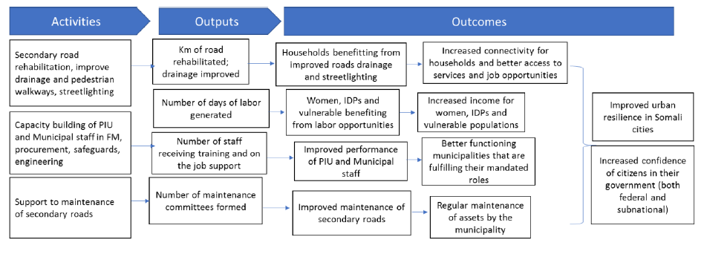

- The PCU, mandated to lead coordination of the Project, seeks to hire a firm to assist it with developing and undertaking the project baseline survey in the four participating cities of Mogadishu, Garowe, Kismayo, and Baidoa. In coordination with the PCU, the firm will work closely with the municipal PIUs and the World Bank Task Team.

- Scope of Work

- In line with the objectives, a project baseline will be developed through a consultative and participatory manner using a mixed methods approach that captures quantitative and qualitative data in line with the project results framework.

- The firm will present a recommended survey methodology, such as to document trends and issues related to access to key urban infrastructure and services, perceptions of municipal government visibility and capacities in delivering key urban infrastructure and services, through the following:

  - A desk review using existing datasets/literature to derive relevant socio-economic information, such as per capita consumption, employment, housing and amenities, public assets, power dynamics, etc., to help inform the approach and construct the baseline.
  - A sampling framework that identifies random selection of households in selected enumeration areas, list of key informants to be interviewed, and number and types of population groups to be interviewed through focus group discussions (FGDs).
  - Household surveys based on a random sample of listed households in selected enumeration areas linked to indicators in the results framework and relevant socio-economic/poverty metrics, also supported by interviews and direct observation.
  - Settlement survey using key informant interviews, direct observation, and secondary data (if available) to develop settlement profiles, identifying relevant social and economic indicators and current and anticipated development trends (population, etc.). This includes documenting characteristics of groups of particular concern, such as internally displaced persons (IDPs), host communities, youth, women of all ages, etc.
  - FGDs and Key Informant Interviews (KIIs) of government and community representatives and vulnerable groups.

- The firm will design a baseline methodology and survey in English and Somali in line with the following considerations:
  - Based on the acquisition of requisite permissions (national, local) and adherence to relevant code of ethics and practices for survey research, as well as insurance coverage of the survey team.
  - Provision of a Field Procedure Plan detailing protocols and guidance for all field work, including team composition, roles and responsibilities, activity schedule, selection and replacement of households and key informants, securing consent, logistics, security, data collection using mobile phone technology (using Open Data Kit, management, and visualization (maps), and quality assurance, verification, and supervision, while allowing for course correction/substitution as needed. This Plan includes the development and roll out of a training program, such as field pre-testing of the data collection instruments. The firm should also provide training materials, consent forms, and a brief field manual to help operationalize the Plan. The field team should also meet two to three weeks after the start of field work to review progress, issues, and trouble-shoot (e.g., for 2-day meeting), as well as hold weekly check-in sessions between the different survey team leads to review and track of progress.
  - Provision of a Data Entry Program, specifying range and consistency checks, coding, course-corrections, and data management, which allows for data aggregation and cross tabulation, supporting flexible, yet robust, systems and checks. For the quantitative survey, data should be captured through computer-assisted personal interviews (CAPI) using smartphones or tablets or computer assisted telephone interviews (CATI) and voice recordings. The firm must therefore provide at least a full-time project manager, data manager, data entry agents, enumerators and field supervisors.
  - Pre-testing and enhancement of survey instruments, monitoring efficiency, effectiveness, and quality of the applied field and data entry procedures in the study area (e.g., 30 households in two enumeration areas). Pre-testing will help eliminate any ambiguities, ascertain the importance and relevance of questions, and ensure that skip logics in questionnaires are accurately set.
  - Detail how the proposed methodology will be implemented in light of the ongoing coronavirus pandemic and security considerations.

- This firm must consult government to validate and approve the baseline approach at all stages of the assignment. It will aim to strengthen the coordination lead capacity of the PCU under the MoPW and will ensure engagement with the municipal PIUs.

- Implementation of baseline data collection in all sample locations, followed by data compilation, cleaning, entry, and analysis.

- The firm will present project baseline findings and analysis (includes maps) which the PCU and WGB will discuss and validate with the municipal PIU and other stakeholders.

- All information produced under the assignment should be managed discretely and securely, to be the property of and handed over to government counterparts in digital format.

D. Team Composition, Qualifications and Experience

- The firm is expected to have the following staff:

  - Project Manager/ Team Leader (Full time)
The key expert proposed for the position of project Manager/ Team Leader must possess a minimum of Master’s degree in Project Planning and Management, Political sciences, Business Administration, Development Economics, Statistics, Mathematics or related fields. The Team Leader will possess at least 10 years of experience.

  - Field Supervisors (Full Time) [Number of positions: 04]
The key experts proposed for the position of Field Supervisors (Deputy Team Leader) must possess a minimum of Master’s degree in Development studies, Sociology, Political science, Business Administration, Management studies or related fields. A Post Graduate qualification in Monitoring and Evaluation will be a plus. The field supervisors will possess at least five years of working experience in Somalia.

  - Data Analysts/Data Managers (Full Time)
This position will be responsible for leading data analysis and management. S/he will also be responsible for designing data entry screens. The key experts for the position of Data Analyst/ Data Manager must possess a minimum of Bachelor’s degree in Computer Science/Mathematics, Applied Statistics or related fields. The Data Analyst must be familiar with at least one data analysis software for quantitative and qualitative analysis such as SPSS, Stata, R, Nvivo or Atlas ti. They will possess at least a minimum of five years’ experience in Data analysis and management.

  - Data entry agents (2)
The Data entry agents will work closely with the Data analyst/ manager to ensure accurate data capture and entry using well designed data entry screens. The Data entry agents will possess a minimum of Bachelor’s degree in Sociology, Development studies, Public Administration or related fields. The data entry agents will possess at least two years of data entry experience and basic analysis using MS excel. They should be familiar with English and Somali languages.

  - Interviewers/Enumerators
The interviewers/ data enumerators will be responsible for administering the questionnaires and checklists for data collection. They will also be responsible for transcribing qualitative data obtained from FGDs and KIIs. They will possess a minimum of a Diploma on Social works, Political studies, Public Administration, Community Development or related disciplines. The Interviewers/ enumerators must possess at least one year’s experience in data collection in a development project environment will be a plus. Experience working as a Research Assistant will be an added advantage. They should be familiar with English and Somali languages.

  - Community Focal Persons
The community focal persons will act as key contact points at community levels during data collection. They will guide the enumerators and lead them to the authorities for formal introduction during the surveys. They will also lead the survey teams to the targeted/ sampled respondents/ households during the data collection process. They will be charged with the responsibility of mobilizing participants of the relevant age categories for the FGD sessions. The selected focal person should be resident within the community. No academic qualifications are required for this role, however, possession of one will be an advantage.

- Reporting and Timeline

The 6-month assignment is expected to start in December 2020/January 2021 and be completed by June 2021. The selected firm is expected to deliver the following:
  - An inception report after the signing of the agreement detailing the desk review results, contextualized sampling framework, coding strategy, data collection methodologies, permits, and work plan;
  - Draft survey instruments in English and Somali, FGD guiding questions, and KII guiding questions including a proposed list of participants;
  - A progress report on the functionality of the field-tested survey instruments and enhancements, and the final survey instruments, sampling frameworks, data management protocols, and trainings. In addition, the firm should produce short weekly progress reports on data collection progress, including number of household surveys or FGD completed, etc.
  - Draft baseline report providing a comprehensive overview of the applied methodology, findings/analysis, limitations, and references;
  - Briefing of the key findings to relevant stakeholders; and
  - A final report with a PowerPoint presentation, professionally edited hard and digital copies. This includes training materials, survey data (Excel or SPSS compatible formats), transcripts, and photographs.

Table 2: Delivery Schedule
Outputs | Date
a. Inception Report | 2 weeks from signing of the contract
b. Draft survey instruments/guiding questions | 4 weeks from signing of the contract
c. Progress report, with final survey instruments | 6 weeks from signing of the contract
d. Draft baseline report | 20 weeks from signing of the contract
e. Briefing materials | 24 weeks from signing of the contract
f. Final baseline report | - weeks from signing of the contract

F. Payment Schedule

- Payments will be based on the following schedule:

Table 3: Payment Schedule
Stage | Proportion of total payment
Signing of Contract
Inception report | 20%
Final survey instruments, sampling frame, and data management protocol | 20%
Draft baseline report and PowerPoint presentation | 30%
Final baseline report | 30%

Qualifications and Experience

- The selected firm should demonstrate key successes and skills in:
- Engaging in impact evaluation assignments with the World Bank, the UN system, and government donor agencies;
- Successful organizing mixed method approaches to data collection, including robust data management and statistical analysis;
- Mobilizing logistics and networks for data collection and appraisal;
- Knowledge of CS-Prom, SPSS, and Stata; and basic skills in qualitative data analysis either manually using thematic analysis or use of software;
- Project work experience in Somalia and/or familiarity with the country context an asset;
- Previous successful collaboration with the Somali government a plus;
- Track record in developing and conducting various types of evaluation, including qualitative and
- quantitative data collection;
- Familiarity with sensitive populations and participatory, community-based approaches to public service delivery advantageous;
- Working in fragility, conflict, and violence and conflict-disaster nexus situations;
- Excellent workflow management and task organization skills;
- English and Somali language; and
- Ability to work with communities in relevant local languages would be an advantage.

Data Properties

- All primary data collected during the contract is the property of the World Bank and the Government of Somalia. The use of primary data without the consent of the World Bank and the Government of Somalia is strictly prohibited. The firm shall store complete survey instruments and supporting materials for a one-year period following completion of the field work and the World Bank reserves the right to access them at any time during that period.

I. Selection Method

30. The Consultancy Firm will be selected using Consultant’s Quality and Cost Based Selection (QCBS) method as specified in the World Bank’s “Procurement Regulations for IPF Borrowers (“Procurement Regulations”) dated July 2016 and revised in November 2017 and August 2018, and is open to all eligible Proposers as defined in the Procurement Regulations.

J. Research Questions

- The baseline will address the following research questions with corresponding key indicators:
Table 4: Sample Research and Indicators
Research questions | Indicators
What is the contribution of SURP II on poverty reduction? | Per capita consumption and expenditure, poverty transition, assets, housing and amenities, employment (types of jobs, status of employment, income etc.
Does SURP II enhance utilization/access to basic services (health, education, WASH, transport, public markets, flood risk management, etc.) and jobs | - Access to key socio-economic facilities (travel time, travel costs)  - Access to jobs (commute time, travel costs, diversification of employment opportunities, income levels)  - Quality of existing roads and drainage and any adverse impacts of the poor quality of roads and drainage e.g.- health, flooding, etc.  - Housing prices (cost of rent), land prices, types of land ownership  - Investments in properties (any improvement in housing)
Does SURP II enhance municipal governance? | - Level of trust/visibility of municipal government  - Level of satisfaction with municipal provision of basic services
Who benefits from SURP II? | Vulnerable groups, including urban poor, women, IDPs, youths, minorities, people living with disabilities, elderly, etc.), as well as host communities
Does SURP II increase community’s awareness and participation in the provision of urban infrastructure services? | Incidence and quality of local participation in decision-making, access to Information, poverty and access to services perception
Are government officials and communities satisfied with SURP II? | - Perception and satisfaction of benefit and project impact  - Ownership and sustainability of infrastructure

- Reference Materials

- A range of reference materials and support will be supplied, as required, by the PCU, municipal PIUs, and the World Bank Task Team to the selected firm, including the Project Appraisal Document, Project Implementation Manual, Environmental and Social Management Framework, municipal institutional assessments, government papers, such as on land tenure and land rights, and associated studies, etc.

Annex I: SURP II, Priority Urban Investments

Table 5: SURP II, Mogadishu Priority Urban Investments
City | Investment | Length (km)
Mogadishu | Jaale Siyad Road and drainage | 3.7
Mogadishu | Dharkenley Road and drainage | 2.7
Mogadishu | 10 community roads and drainage (in 10 districts) | 11
Mogadishu | interconnectivity roads stormwater drainage | 15.2
Mogadishu | Stormwater drainage | 6.5

Map 1: SURP II, Mogadishu Priority Urban Investments
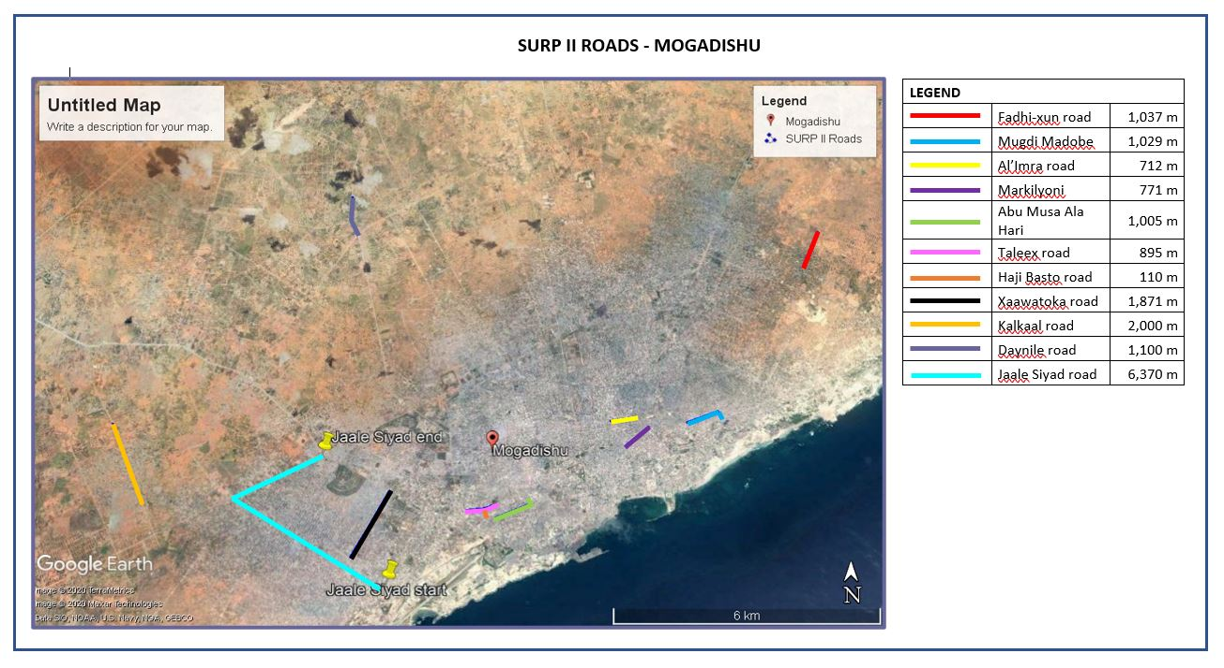

Table 6: SURP II, Garowe Priority Urban Investments
City | Investment | Length (km)
Garowe | 5 urban roads | 7.6
Garowe | Hospital bridge
Garowe | City-wide drainage assessment

Map 2: SURP II, Garowe Priority Urban Investments
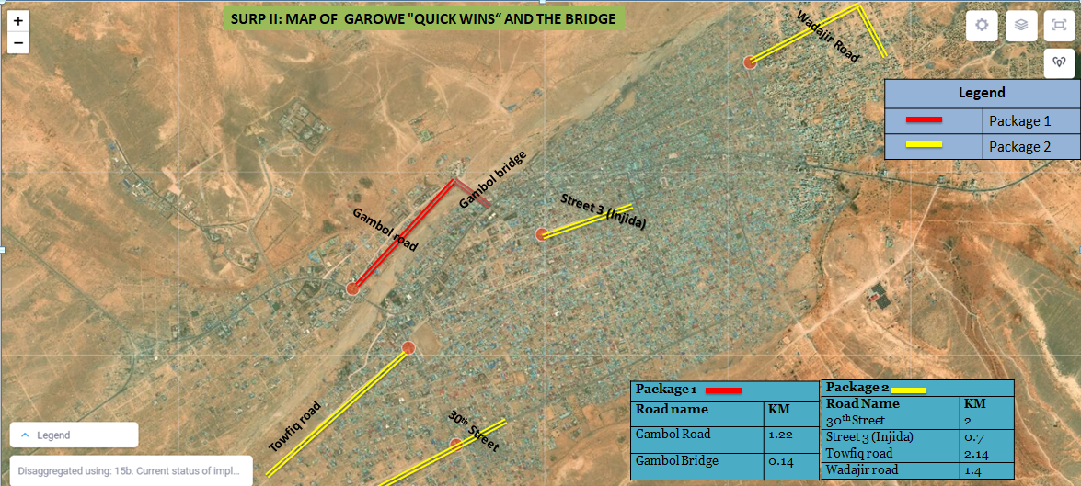

Table 7: SURP II, Kismayo Priority Urban Investments
City | Investment | Length (km)
Kismayo | 7 asphalt roads w side drains, walkways, and street lights | 7.75
Kismayo | 1 asphalt roads w side drains, walkways, and street lights | 3.9
Kismayo | Office block
Kismayo | Material testing lab
Kismayo | Drainage outfalls

Map 3: SURP II, Kismayo Priority Urban Investments
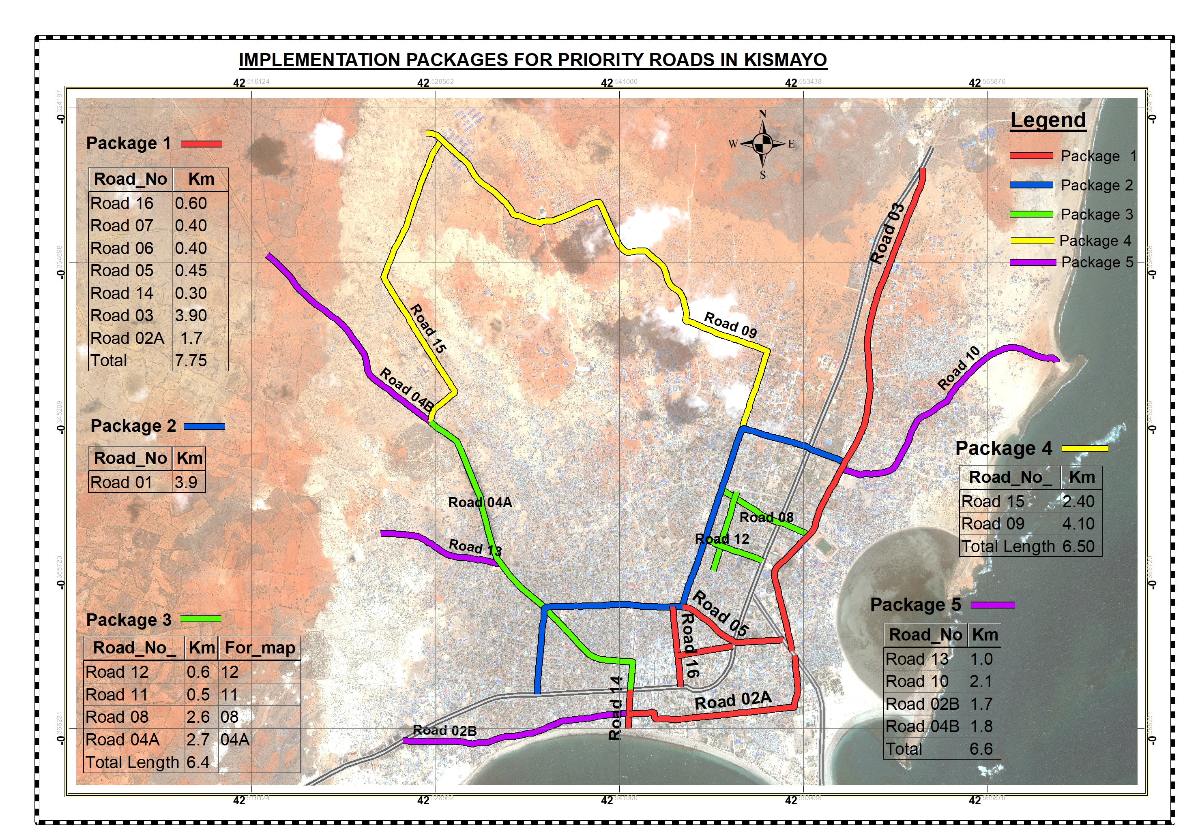

Table 8: SURP II, Baidoa Priority Urban Investments
City | Investment | Length (km)
Baidoa | 2 asphalt roads, w side drains, walkways, street lights, 2 culvery bridges | 3.9
Baidoa | 2 asphalt roads, w side drains, walkways, street lights, existing bridges | 7.1
Baidoa | 1 asphalt road, w side drains, walkways, street lights | 2.7
Baidoa | 4 roads | 8.4

Map 4: SURP II, Baidoa Priority Urban Investments
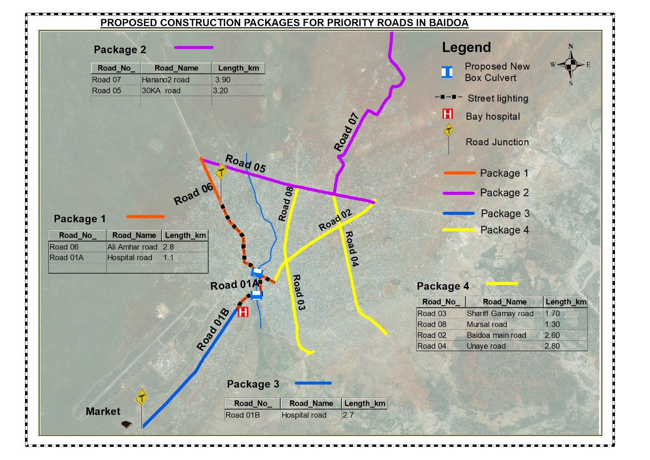

Annex II: SURP II, Results Framework

Project Development Objectives(s)
To strengthen public service delivery capacity of local governments and increase access to urban infrastructure and services in selected areas.

Project Development Objective Indicators

Indicator Name |  | DLI Baseline | Intermediate Targets | End target
To support the construction of key urban infrastructure in targeted cities
People with access to all season roads within a 500 meter range (% female, %IDPs, %host communities) (Number) |  | 3,500.00 | 5,000.00 | 30,000.00
Financed subprojects functioning and delivering services one year after completion. (Percentage) |  | 0.00 | 90.00 | 90.00
Municipalities with clean financial project audits that continue to remain eligible for the project (Number) |  | 0.00 | 4.00 | 4.00
Intermediate results Indicators by Components
Indicator Name |  | DLI Baseline | Intermediate Targets | End target
Urban Infrastructure and Services  Urban roads rehabilitated or upgraded (Kilometers) |  | 0.00 | 15.00 | 45.00
Pedestrian walkways constructed (Kilometers) |  | 0.00 | 5.00 | 10.00
Person days of employment created (days, % female, % IDPs, % host) (Number) |  | 0.00 | 40,000.00 | 100,000.00
Subprojects with post-construction Operations & Maintenance plans (Number) |  | 0.00 | 10.00 | 20.00
Number of women engaged in unskilled labor activities in the project (Number) |  | 0.00 | 15.00 | 50.00
Beneficiaries satisfied that infrastructure met their |  | 0.00 | 60.00 | 70.00
Institutional Strengthening and Analytics
Inter-governmental forum discussions held
between federal/state/municipal levels (Number) |  | 0.00 | 2.00 | 4.00
Municipalities with improved O&M plans |  | 0.00 | 2.00 | 4.00
Project Management and Capacity Building
Project and municipal staff formally trained on
core municipal functions (Number) |  | 0.00 | 35.00 | 80.00
Participants in consultation activities during project implementation (Number) |  | 0.00 | 150.00 | 400.00
Greivances registered related to delivery of project benefits that are addressed (Percentage) |  | 0.00 | 60.00 | 85.00
Women engaged in consultation activities during |  | 0.00 | 30.00 | 100.00
Contingent Emergency Response
Specific Operation Manual developed for crisis response (Yes/No) |  | No |  | Yes
Beneficiaries covered under the activated crisis response (Number) |  | 0.00 |  | 0.00

Monitoring & Evaluation Plan: PDO Indicators
Indicator Name | Definition/Description | Frequency | Data source | Methodology for Data  Collection | Responsibility for Data  Collection
People with access to all season roads within a 500 meter range (% female,  %IDPs, %host communities) | All-season road is defined as a road that is passable all year by the prevailing means of transport (e.g. a car, fire truck, or ambulance which may not have four- wheel drive). Predictable interruptions of short duration during inclement weather (e.g. heavy rainfall) are acceptable, particularly on low-volume roads. Road blocks due to security purposes are also acceptable. The proportion  of beneficiaries that are female, IDPs or host communities will also need to be measured and calculated as a percentage. This indicator will be  disaggregated by city. | Annual | Project progress reports, UNFPA  population figures for districts if available and with support from municipalitie s. | Guidance on people with access: The data on the number of people provided with access can be measured by assessing the kilometers of roads constructed or rehabilitated and estimates of the population in the project area within a 500-meter range that will access these roads (based on population  density estimates by the municipality). 500 meters is roughly equivalent to 5-10 minutes walking time. | Municipalities, PIU, PCU
Financed subprojects functioning and delivering services one year after completion. | These are subprojects that  are still being used by  communities one-year after  completion and handover of  the subproject by the  contractor. Subprojects  affected by natural disasters  or conflict are not considered to calculate this indicator. This is a long term  project and is likely to have  subsequent phases. Those  subprojects completed in  the last year of  implementation can  therefore, be evaluated in  the subsequent phase of the  project. | Annual | Quarterly project reports/Annual reports | Review of quarterly reports and verification of data by the PCU | Municipalities, PIU, PCU
Municipalities with clean financial project audits that continue to remain eligible for the project. | Municipalities that have  clean audits based on the  annual project wide  financial audits.  Municipalities must also not  have any ineligible  expenditures or declared  mis-procurements which  would exclude them from any additional infrastructure  financing from the project. | Annual | Annual project audits | Review of annual project audits | PCU, Federal EAFS

Monitoring & Evaluation Plan: Intermediate Results Indicators
Indicator Name | Definition/Description | Frequency | Data source | Methodology for Data  Collection | Responsibility for Data  Collection
Urban roads rehabilitated or upgraded | Measures cumulative length of all newly constructed and/or rehabilitated roads in the 4 municipalities thereby improving urban mobility. Road-side drains are systematically included in the road improvements and will not be double  counted under the project. | Quarterly | Project quarterly progress reports, Supervision engineers reports | Review of engineering supervision reports and contractor reports | PIUs, PCU, Municipality
Pedestrian walkways constructed | Measures cumulative length of all newly constructed pedestrian walkways in the 4 municipalities, thereby improving mobility of  pedestrians. | Quarterly | Quarterly reports, engineering supervision reports | Review of engineering supervision reports and contractors reports | PIU, Municipalities
Person days of employment created (days, % female, % IDPs, % host) | These are the number of people benefiting from short term employment opportunities created by civil works financed through this project. Percentage of  beneficiaries that are female, IDP, host communities will need to be calculated. The values will  be broken down by city. | Quarterly | Quarterly reports, engineering supervision reports, contractors reports | Review of engineering supervision and contractor reports | PIU, Municipality, PCU
Subprojects with post-construction Operations & Maintenance plans | Subproject specific operations and maintenance plans are to be prepared for each subproject supported by SURP II which include indicative operating budgets and identifies key stakeholders responsible for  maintenance. | Annual | Engineering supervision reports, quarterly reports | Review of engineering supervision reports, quarterly reports | PIUs, Municipalities
Number of women engaged in unskilled labor activities in the project | These are the number of women benefiting from short term employment opportunities created by civil works financed through this project. | Quarterly | Project quarterly progress reports, Supervision engineers reports | Site visits, review of reports | Municipalities/PIUs/PCU
Beneficiaries satisfied that infrastructure  met their needs (number, % female, %IDPs) | Beneficiaries are people or  groups who directly derive  benefits from improved  roads in this project and  their satisfaction with the  infrastructure will be  assessed through  questionnaires in focus  group discussions. The  measure of satisfaction will  need to look at multiple dimensions including the quality of the rehabilitated infrastructure and whether the rehabilitated road has improved their access to services/jobs. Satisfaction to be calculated through focus group discussions and or  surveys. | Mid-term and end project | Mid-term and end project evaluation | Review of evaluation reports | PIU/Municipality, PCU
Inter-governmental forum discussions held between federal/state/municipal levels | The number of meetings held that involve the different layers of the government to discuss issues related to the project, functional assignments related to service delivery,  revenue sharing etc. | Quarterly | Project Quarterly reports | Review of project quarterly reports | PIU, municipality, PCU
Municipalities with improved O&M plans | These are O&M plans that  are informed by the number  of km of paved roads in the  city that needs to be maintained, the institutional  structure within the municipality that would implement the O&M plan and the availability of financing within the  municipality. | Annual | Quarterly  Reports | Review of quarterly  reports | PIU, Municipality, PCU
Project and municipal staff formally trained on core municipal functions | The number of municipal staff trained in procurement, financial environment safeguard management, project  management etc | Quarterly | Quarterly progress reports | Review of quarterly progress reports | PIU, PCU and Municipalities
Participants in consultation activities during project implementation | This indicator measures the level of community engagement in project implementation - this includes in the selection of subprojects, during construction and in the selection of beneficiaries for casual labor and in  maintenance activities. | Quarterly | Quarterly reports, mid- term and end project evaluation | Review of quarterly reports, focus group discussions or surveys in midterm/end project evaluation | PIU, PCU, Municipalities
Grievances registered related to delivery of project benefits that are addressed | This indicator measures the transparency and accountability mechanism established by the project. Grievances would need to be registered and  responded to. | Quarterly | Quarterly progress reports | Review of quarterly progress reports | PIU, PCU, Municipalities
Women engaged in consultation activities during project implementation | This indicator measures the level of engagement of women in project implementation - this includes in the selection of subprojects, during construction and in the selection of beneficiaries for casual labor and in  maintenance activities. | Quarterly | Project quarterly progress reports | Review of quarterly progress reports | Municipalities/PIUs/PCU
Specific Operation Manual developed for  crisis response | An operational manual for  the CERC will need to be developed that outlines the eligible activities to be financed under this component if triggered and the implementation  modalities. |  |  |  | Municipalities, PCU
Beneficiaries covered under the activated crisis response | The number of people benefiting from the CERC if it is triggered. This will vary depending on the amount of funding allocated for this  crisis response. |  |  |  | Municipalities, PIU, PCU

SURP II became effective on February 24, 2020 with a closing date of December 31, 2024.
Africapolis, 2015
Annex I, SURP II priority urban investments.
See the SURP-II Project Appraisal Document for additional state-level costing details, available at <http://documents1.worldbank.org/curated/en/191081576206050578/pdf/Somalia-Second-Urban-Resilience-Project.pdf>
To serve as the point of comparison for the project end-line evaluation.
As the priority investments for Beledweyne and Dhusamareb have yet to be identified, these municipalities are not included in the proposed assignment. Their subsequent inclusion may be negotiated separately through a new scope of work and extension to the existing contract.
Annex II, SURP II, Results Framework
Defined as settlements within 500 meters from each side of the road that will be financed under SURP II.
For 5-10-minute interviews.
For 45-60-minute interviews
At least two FGD per enumeration area and 7-10 randomly selected participants per FGD.
At least two visits per household.
A minimum of five percent of re-visits to a random sample of the evaluation sample to confirm data validity.

